ACHIEVEMENT IN NATIONAL CHILDREN SCIENCE CONGRESS- 2022
SELECTED AT REGIONAL NCSC HELD AT KV RAIGARH
REPRESENTED THE RAIPUR REGION IN KVS NATIONAL NCSC HELD AT BENGALURU IN SUBTHEME -3 UNDER JUNIOR GROUP
YASHI TRIPATHI(VIII) ( TEAM LEADER) CHANDANA Y. GOWDA (IX) GROUP MEMBER
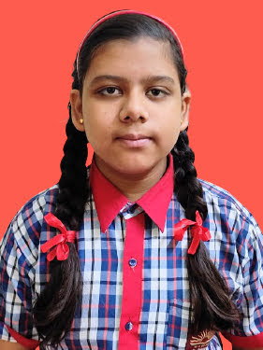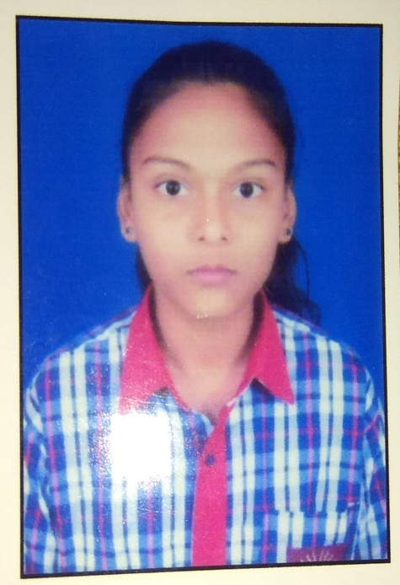

- ACHIEVEMENT IN GREEN OLYMPIAD – 2022

SATVIK GIRIYA OF CLASS-IV PARTICIPATED IN GREEN OLYMPIAD UNDER THE THEME – ENVIRONMENT, SUSTAINABLE DEVELOPMENT AND GREEN SKILLS, AND HAS BEEN AWARDED CERTIFICATE OF DISTINCTION.

- PRATIK DEWANGAN, CLASS-XII (2021-22) GOT SELECTED IN NEET FOR MBBS AT ESIC MEDICAL COLLEGE, FARIDABAD DELHI NCR
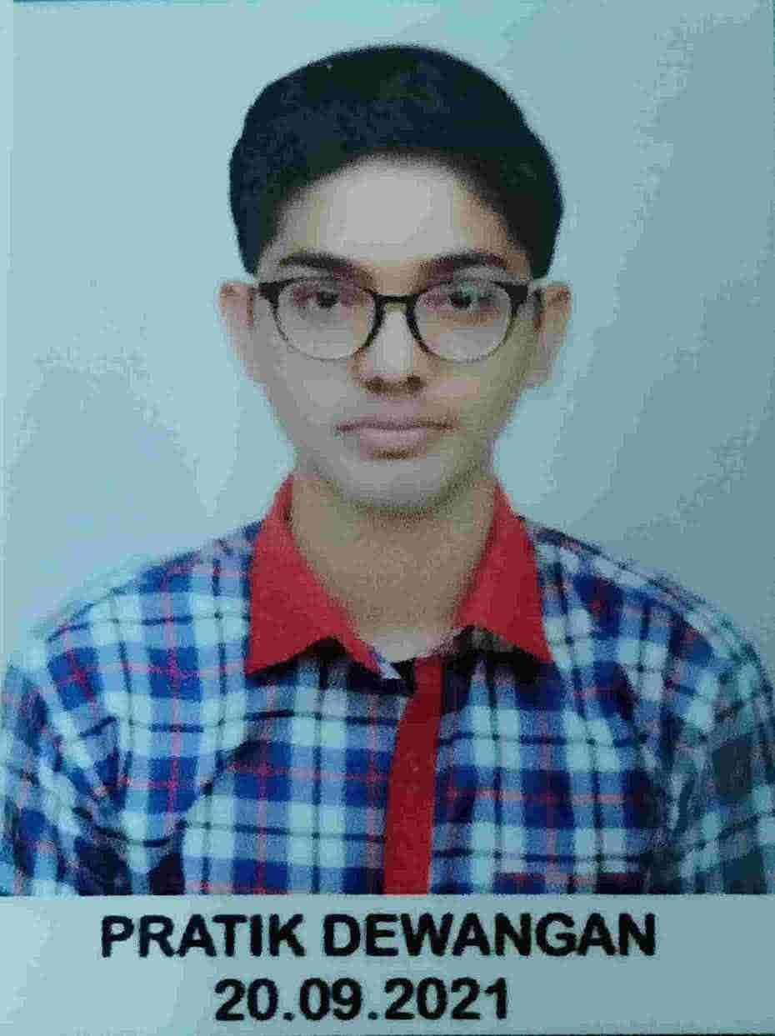

- INSPIRE AWARD SCHEME 2022-23, STATE LEVEL SELECTION
  - POORVI SAHU – CLASS-VIII
  - YASHI TRIPATHI – CLASS-VIII
  - AMIT KUMAR RATHORE – CLASS-X

