KENDRIYA VIDYALAYA CISF, BHILAI
SESSION – 2022-23
 | REGIONAL/ NATIONAL ACHIEVEMENTS
 | SPORTS ACHIEVEMENT
ROAP SKIPPING | BOYS & GIRLS - | 8 | 4 Boys | 4 Girls
S. No | Name of Students | Medal
1 | Pranjal Thakur | 1 Bronze | 2 Silver
2 | Aryan Paswan | 2 Silver
3 | Atharv Nirmalkar | 1 Silver | 1 Bronze
4 | Jeet Patel | 1 Silver
5 | Chandana Y Gowda | 1 Silver
6 | Divya Meshram | 2 Gold | 1 Bronze
7 | Rani Mog | 1 Gold | 1 Silver | 1 Bronze
8 | Amisha Kumari | 1 Gold | 1 Bronze
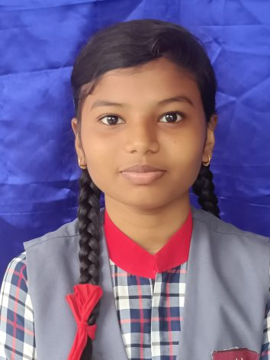 | 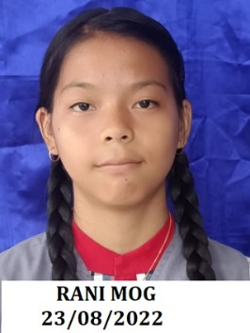 | 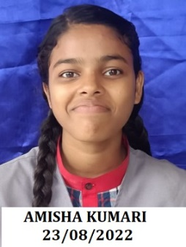 | 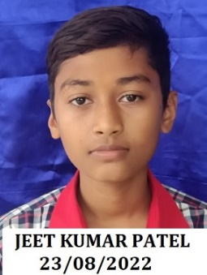 | 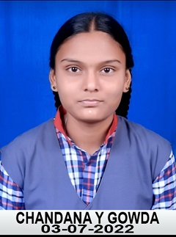
Divya Meshram | Rani Mog | Amisha Kumari | Jeet Patel | Chandana Y Gowda
VOLLEYBALL
9 | Alok Pandey | Quarter Final
10 | Rakshit Kumar Nagle | Quarter Final
 | 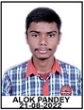 | 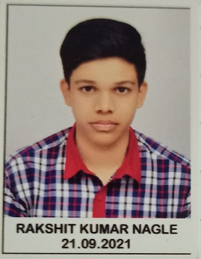
BOXING
11 | Bhavesh Tandan | Quarter Final
 | 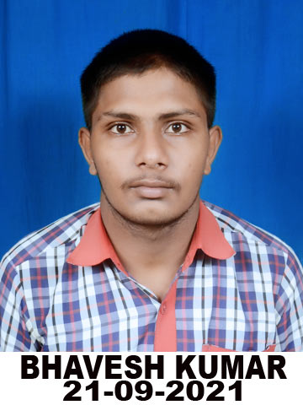
FENCING(तलवारबाजी) Open National Games Held at Ahemdabad
12 | Gaurav Chaudhary | 1 Silver | 1 Bronze
 | 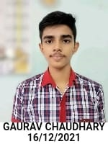
Regional Level U-17 Boys Volleyball - |  |  | 2 nd Position
KVS CLUSTER LEVEL PARTICIPATIONS & MEDALS
ACHIEVMENT
S. No | Name of Events |  | Position
1 | Kho-Kho | Girls | I
2 | Kho-Kho | Boys | II
3 | Kabaddi | Girls | II
4 | Kabaddi | Boys | III
Individual Athletics
 | Position | No. of Students
I | First | 5
II | Second | 10
III | Third | 5

